**APPIAN ESSENTIALS**

**Introduction :**

* Enables you to accelerate your business by discovering, designing and automating your processes.

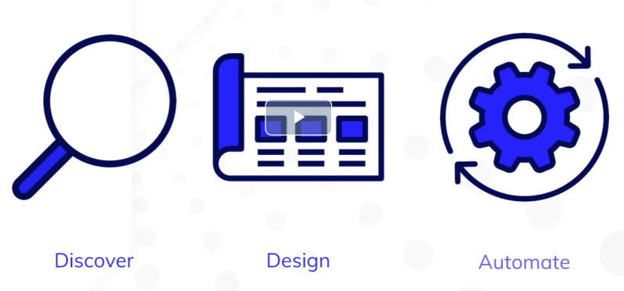

* Appian is a unified low-code platform with key capabilities – process mining, workflow and automation

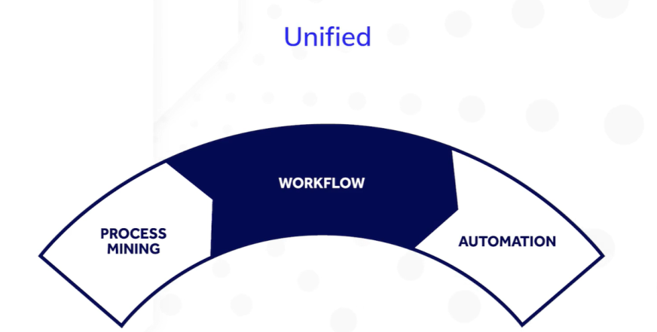

* Appian is a low code platform which provides users a wealth of low code tools :

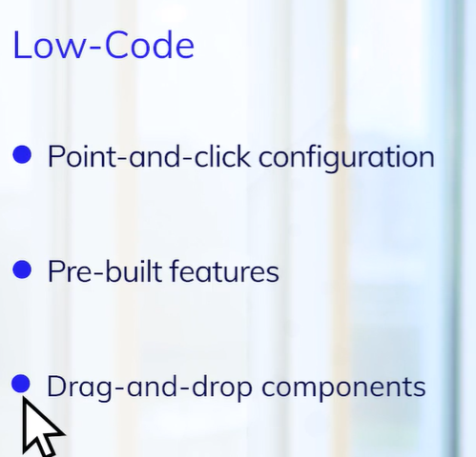

* As a unified platform, Appian provides developers with visibility and control.



**Workflow :** Sequence of data tasks that process a set of data.

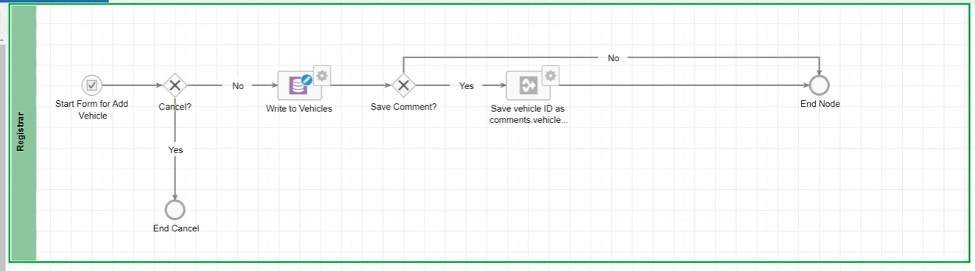

**Process Mining :** Allows you to analyze processes at your organization using event logs. Provides automation opportunities for Non-Appian users.

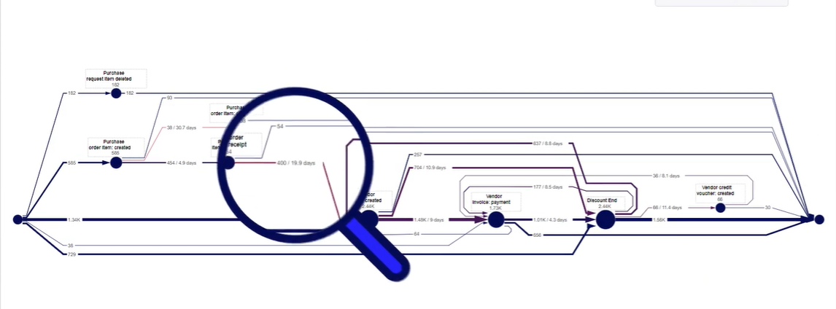

**Automation :**

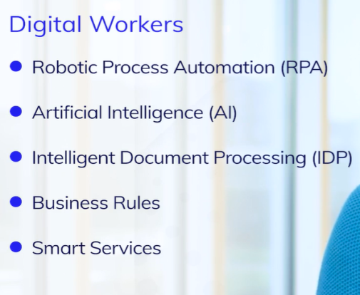

**RPA :**

* Allows you to automate repetitive and rule based manual tasks such as copying/pasting data and searching online for information.
* In Appian, you can create RPA using point-and-click interface that will enable you to easily record, monitor and troubleshoot interactions.

**IDP :**

* Helps to process documents such as invoices or contracts automatically which can help increase productivity and reduce errors.
* Uses ML and AI to classify PDF docs, and then extract data for use in Appian apps and workflows.
* **Appian Portals :** With Portals, you can open your internal application to external, un-authenticated users.

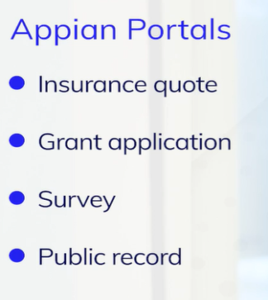

* **Appian Solutions :**

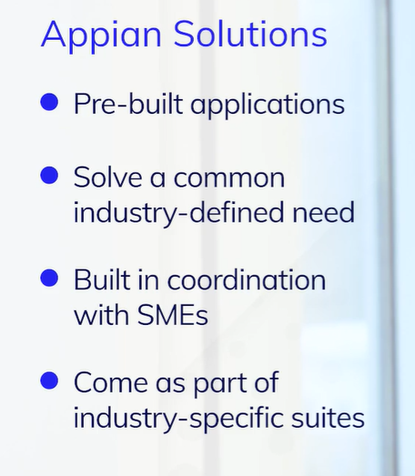

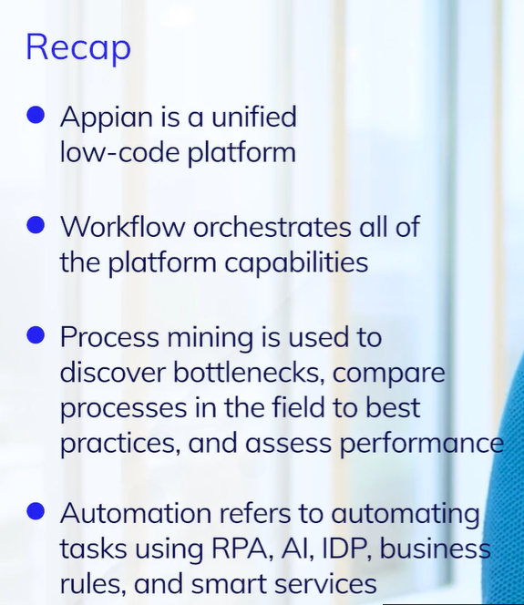

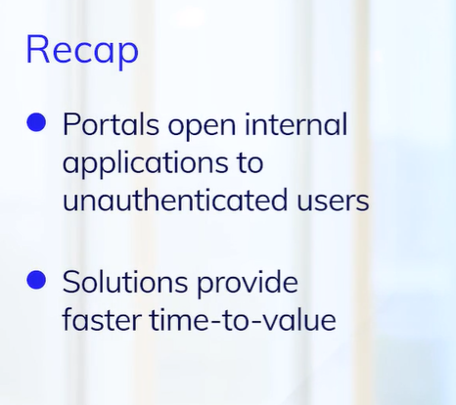

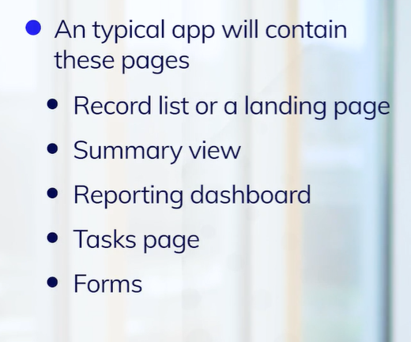

* Low code development means developing without coding, with using point and click configuration (records), patterns & templates & drag drop components (interfaces).